**Placement Details:**

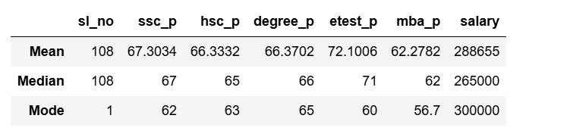

From above analysis,

The students are got marks above average in SSLC, HSC, MBA examination.

They got good marks in entrance test.

The salary outlier is 20000, average salary is 265000 and repetitive salary is 300000.